DEPARTMENT OF SOFTWARE ENGINEERING
ARTIFICIAL INTELLIGENCE (LAB)

Name: DANIYAL YOUSAF AAMIR SAIFI
Roll No. su92-bsaim-f25-097
Section: BSAI-3B
Lab 5: Minimax & Alpha-Beta Pruning
Course Code: CA1601400/CS4944

TASK 1:

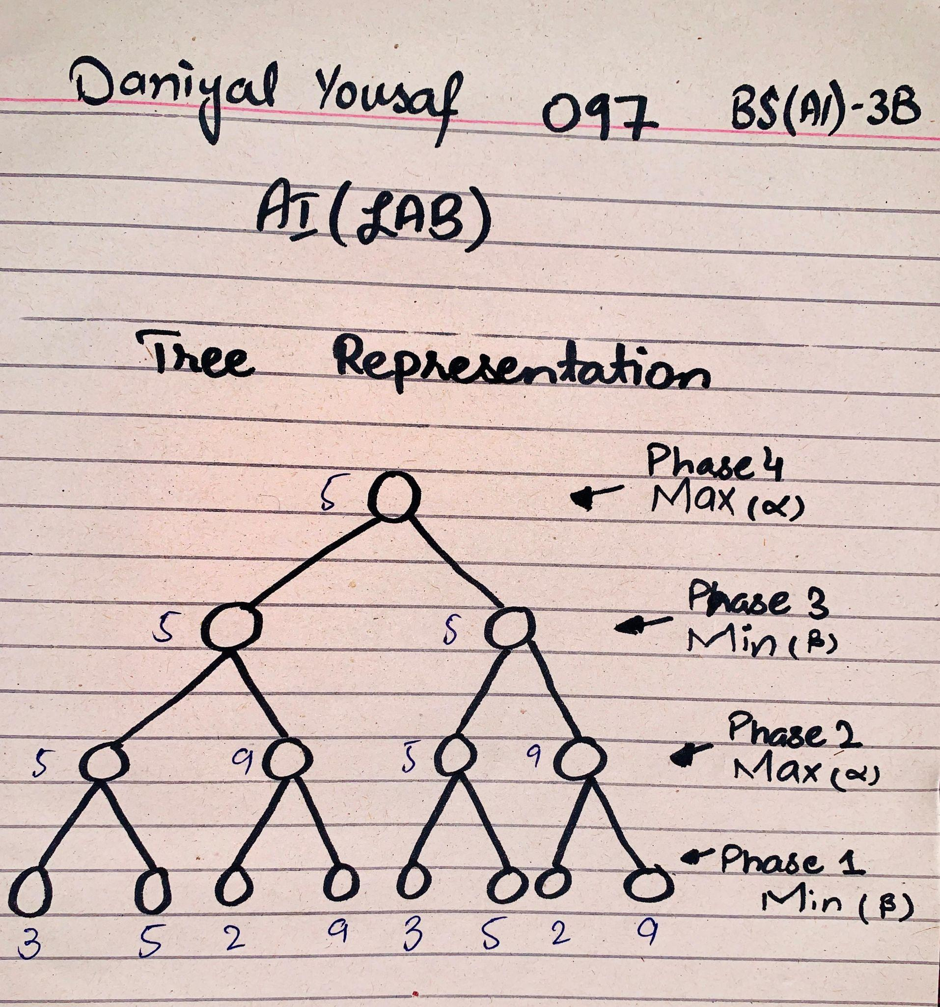
Tree Representation (Explanation):

Phase 1: Show all the Leaves.
Phase 2: For Max Term - I choose a Max value among the nodes with leaves pair [3,5] & [2,9]
5 wins among [3,5] and 9 wins among the [2,9] pair in both nodes.
Phase 3: Represent Min Term (From fig. above) - [5,9] pairs further evaluate and 5 wins at this stage at both the nodes because 5<9.
Phase 4: Which deals with Max Term - So [5,5] pair 5 wins.

__________________________________________________________

TASK 2:

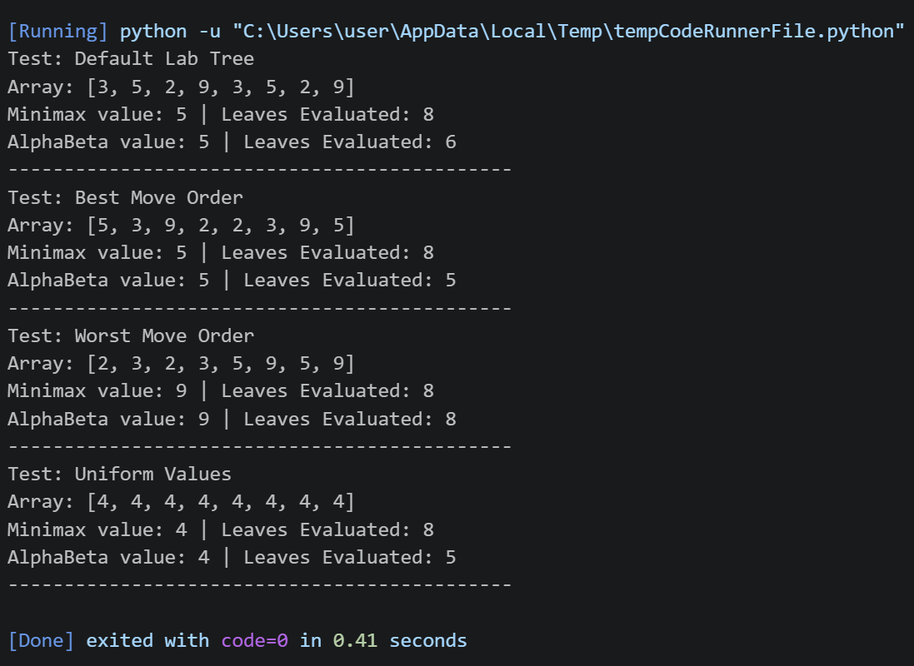

__________________________________________________________

TASK 3:

Case | Left (Sequence) | Root Values | Minimax Leaves | Alpha-Beta Leaves
Default Tree | [3,5,2,9,3,5,2,9] | 5 | 8 | 6
Best Move Order | [9,5,3,2,9,5,3,2] | 5 | 8 | 4
Worst Move Order | [2,3,5,9,2,3,5,9] | 5 | 8 | 8
Uniform Values | [4,4,4,4,4,4,4,4] | 4 | 8 | 5

Result:

- Default Tree [3,5,2,9,3,5,2,9]: Standard Minimax visits all 8 leaf nodes to find the optimal root score of 5. Alpha-Beta pruning arrives at the exact same root value of 5 while evaluating only 6 leaves, successfully skipping 2 unneeded branch evaluations.
- Best Move Order [9,5,3,2,9,5,3,2]: Placing the highest potential values first lets the alpha and beta bounds update immediately. This triggers early cutoffs, cutting the workload in half by evaluating only 4 leaves.
- Worst Move Order [2,3,5,9,2,3,5,9]: Placing smaller values first delays updating the alpha and beta bounds. Because the cutoff condition (alpha>=beta) is never met early, Alpha-Beta is forced to check all 8 leaves, performing identical work to standard Minimax.
- Uniform Values [4,4,4,4,4,4,4,4]: When every terminal score is identical, alpha and beta quickly become equal (alpha=beta). This triggers early cutoffs across the subtrees, reducing the required checks to only 5 leaves.

__________________________________________________________

Reflection Question:

1- Learning: I learn the concept of minimax and alpha-beta pruning.

2- Real-World Example: Trading Bots use min-max principles for making the strategies in bidding.

3-Surprise Element: I check Bad moves first and I am surprised to see it breaks the pruining.

4- Next Time: I will sort the moves from best to worst to see how the flow changes.

